

National Textile University
Department of Computer Science
Subject

Operating System

Submitted to:
Sir Nasir Mahmood

Submitted by:

Ahmad Farooq

Registration Number
23-NTU-CS-1128

Home Task
01

Semester
5th

Verification of WSL and Ubuntu installation:
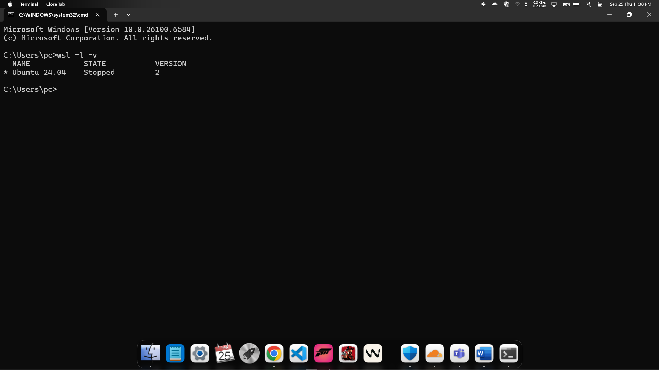
Update Ubuntu Environment:
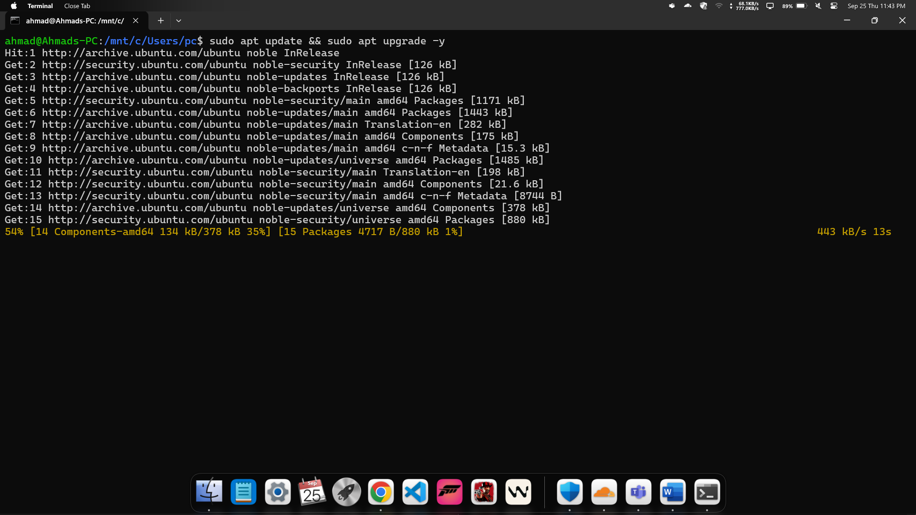

Git & GitHub
UserName and Email configuration:
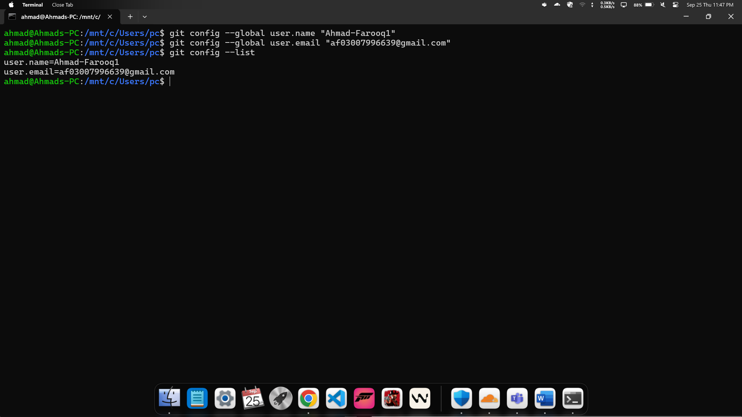
Testing SSH key:
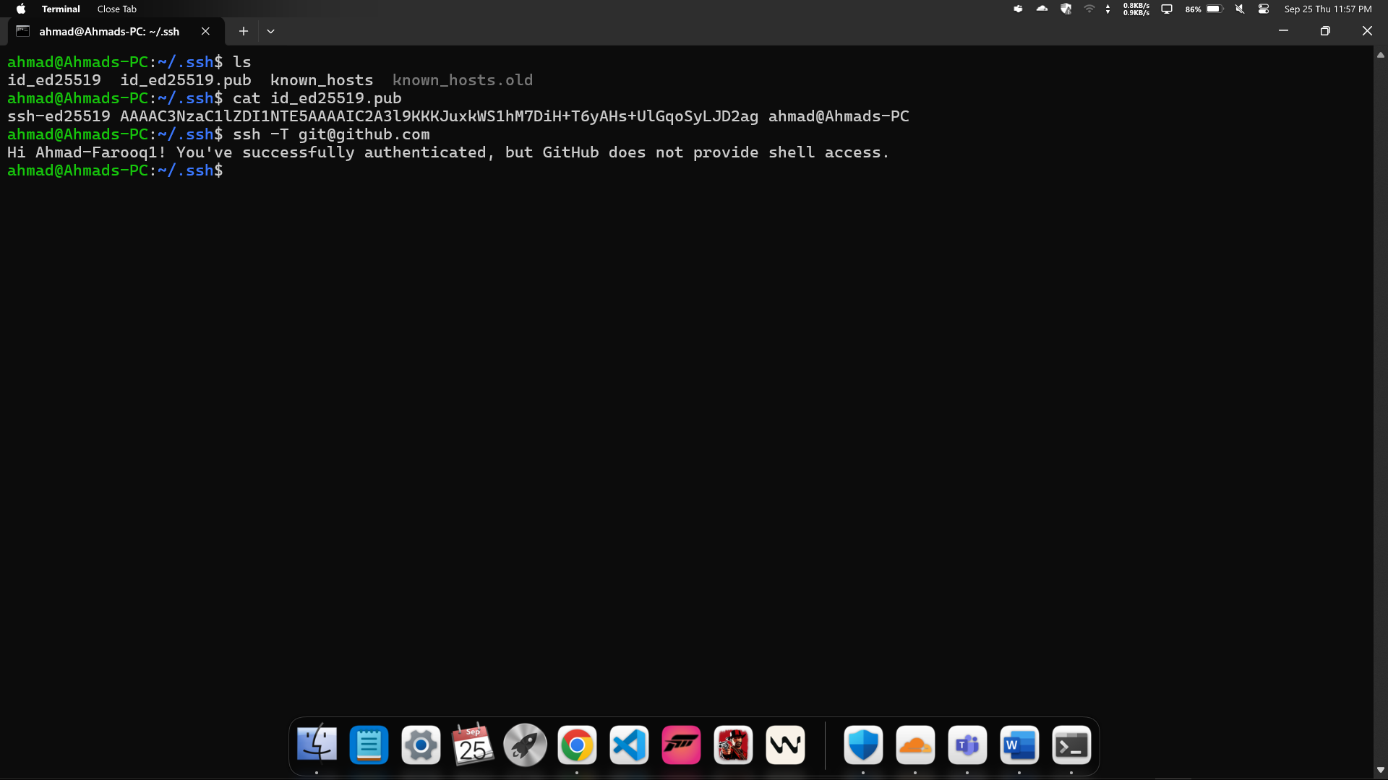

Install Build Tools:
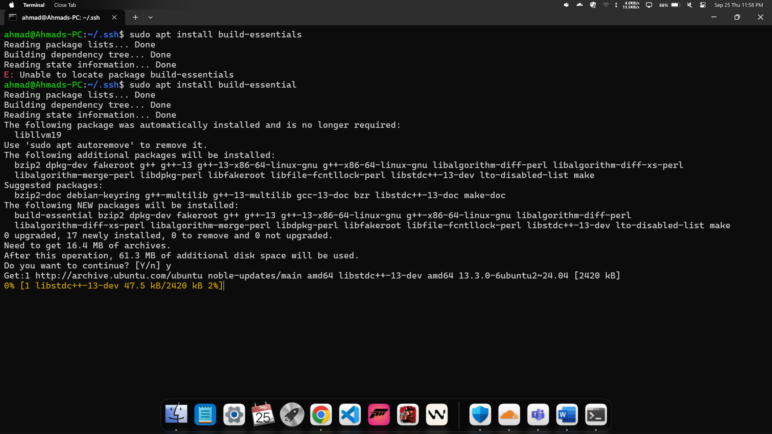
GCC version :
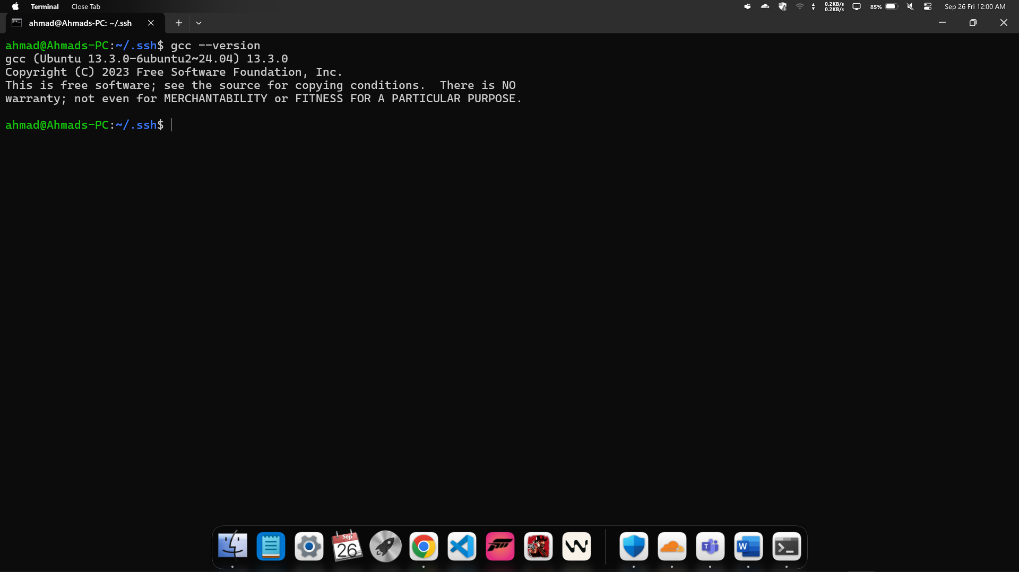

Creating First C file:
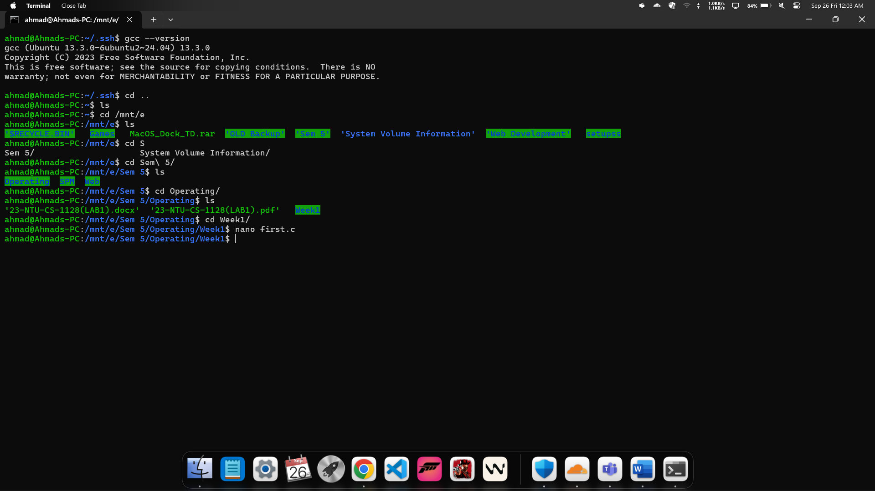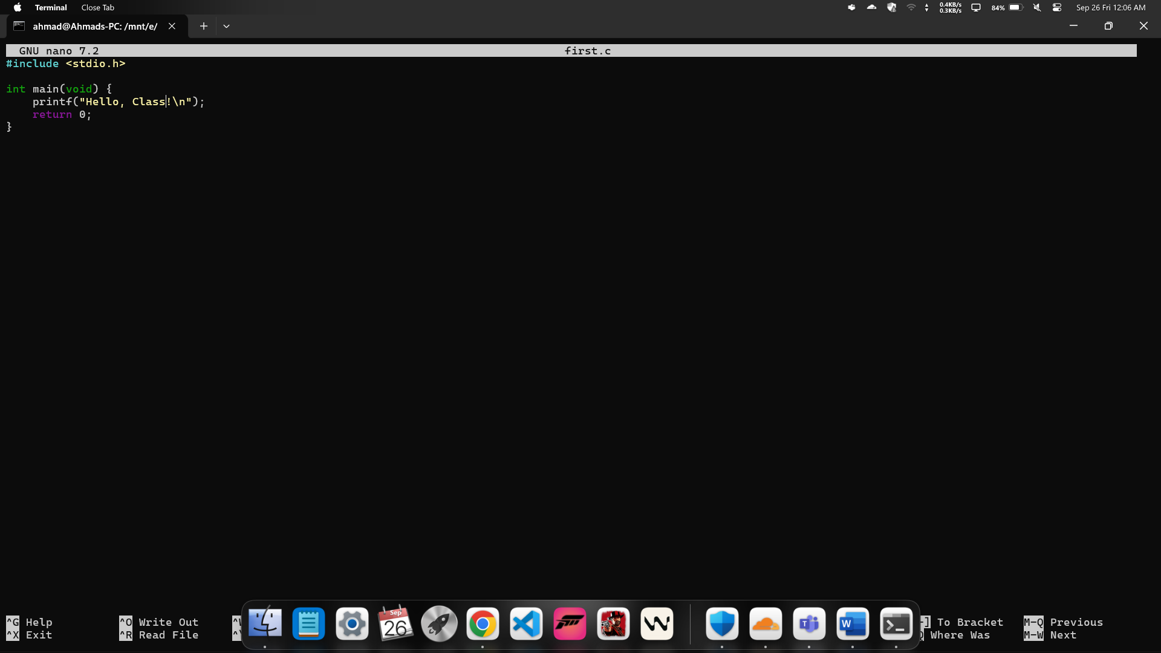

Executing C file:
